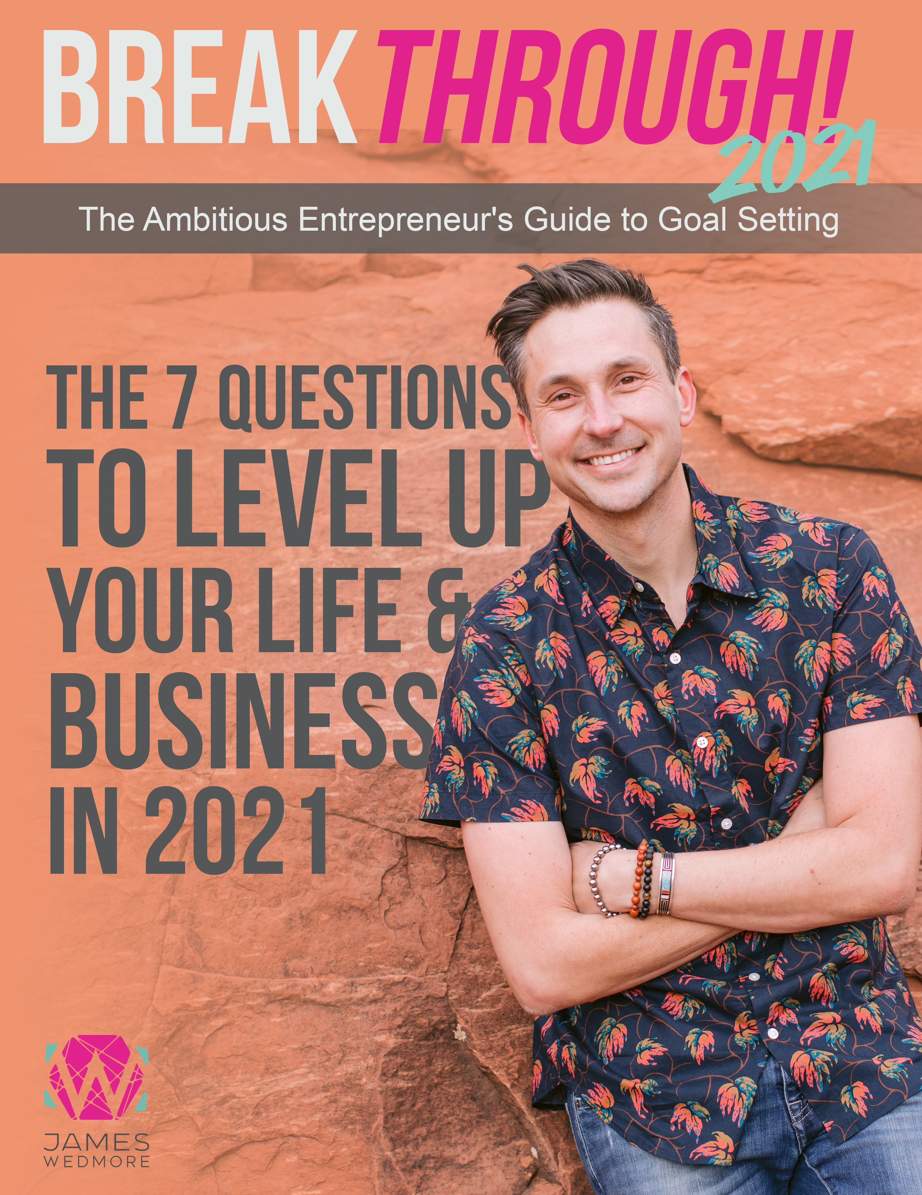

In 15 years of running an online business, there has been positive growth each year. Some years have seen EXPLOSIVE growth! This is what I refer to as QUANTUM LEAPS of growth. In 2014, I went from $280,000 (2013) to ($1.2M) by the end of the year.
Then, just two years ago, we went from $3M
to $9.4M in one year.

Each of these “quantum leaps” requires something: A breakthrough.

A breakthrough is when you discover what has been getting in the way, and you go beyond yourself, and your self- imposed limits to do, create, or experience the IMPOSSIBLE.

This is what I’m here to help you with. This is not your grandmother’s goal-setting guide. In fact, this isn’t about GOALS at all. Heck, it’s never been about the GOAL. It’s about the GAME.

And there is a world of difference between the two. In fact, my goal hasn’t changed in years! My goal is to help entrepreneurs make more money and create a bigger impact. I accomplish that goal every day. Everything I do in my business is for that GOAL.

The Game is the challenge I choose to take on for myself in HOW I will hit that goal.

Together, we will not just create a GAME for your next 12 months... but we will create one that you are actually passionate about playing. And most importantly: we’ll create a GAME that you’re going to win.

So, drop everything you think you know about goal-setting. Leave it at the door. Come with an open mind and an open heart, and be willing to try on something new...

What do you have to lose?

Part 1: Stop, Drop, & Roll
Marking Complete on your Last 12 Months

THIS is the biggest missing piece with anyone’s “goal-setting” process: they try and create a goal for the new year without being complete with the last year. That’s like trying to paint a work of art on top of a messy canvas. It limits you more than you can imagine.

And we won’t go too deep down the rabbit hole of all the performance coaching I teach my clients, but a MASSIVE aspect of your future is actually being created by your PAST... or rather, your interpretations about the PAST.

Most of us carry our failures and let downs around with us like a bunch of heavy rocks in a backpack. And as the years go by, the bag gets heavier and heavier, which means doing, creating, and BEING gets harder and harder.

WOULDN’T IT BE NICE TO LET GO OF THE BAG? WOULDN’T IT BE NICE TO FEEL LIGHT AGAIN? FREE TO DREAM? RISK? CREATE?

Unless you would love to repeat your last 12 months (with no growth!), take the time to do Part 1, which is all about Stop, Drop, & Roll!

STOP WHAT YOU ARE DOING AND PAUSE.

DROP WHAT’S NOT WORKING...

AND LET’S ROLL WITH WHAT IS!

Now, let’s get started! Write down your answers to the questions below either directly onto a printed out page or on a separate piece of paper (trust me, you’re DEFINITELY going to want to DO this step).

QUESTION 1: WHAT HAPPENED IN THE LAST 12 MONTHS
(PERSONALLY, PROFESSIONAL)?

- Look for job. Improve, but still not success. Have a lot of opportunities. Need to improve interview skill? And others?
- My own stock management. Still not clean the account and portfolio. Come up strategies to win.
- Kcancer business. Still don’t know or exactly make money. Need to have clear goal on how to make the first $100, then $1000, $10,000 per month.

QUESTION 2: WHAT WERE THE LESSON(S) OF EACH THING YOU EXPERIENCED THAT YOU CAN TAKE WITH YOU INTO THE NEXT YEAR?

- Job hunting. Improve interview skill. And follow up
- Stock management. Come up clear strategies on how to consistently make money
- Come up clear paths to make money from my business activities.

QUESTION 3: WHO WERE YOU IN JANUARY?
- Job hunting

- Stock management

- Run my own business??

QUESTION 4: WHO ARE YOU NOW?

There are limited progress in my activities

- Job hunting
- Stock management
- My own business activities

QUESTION 5: WHAT ARE YOU STILL HOLDING ONTO FROM 2020 THAT IS TAKING UP SPACE (MENTAL, EMOTIONAL, PHYSICAL)?

WHAT WILL THERE BE ROOM FOR WHEN YOU LET THAT GO?
- Could not find job
- Don’t know how to manage my stock account
- No sign of business profit

EXERCISE: Burn the questions and answers above (and make sure to take a video of you doing this exercise and tag me on Instagram @jameswedmore!).

Part 2: Creating a Breakthrough in
Business over the next 12 Months

If you have successfully completed Part 1, now it’s time to create your GAME for the next 12 months. It’s important here that you feel GOOD before starting. If you feel stressed, overwhelmed, or rushed, find a better time to do this very important exercise.

What we are about to do is the MOST essential responsibility of any Visionary, Leader,
or Digital CEO... because if you don’t do this for your business, who will?

Ok, in a good-feeling state, let’s do this!

1. HOW WILL YOU KNOW WHEN YOU’VE HAD A BREAKTHROUGH?

- WHAT SPECIFIC OUTCOMES WOULD TELL YOU THAT YOU’VE HAD A BREAKTHROUGH?

Have a full-time permanent job

B. WHAT WOULD EXPERIENCING THAT BREAKTHROUGH GIVE YOU?

Life security

- WHAT WOULD YOU NEED TO HAPPEN IN ORDER FOR YOU TO KNOW YOU ARE ON TRACK TO EXPERIENCE THIS BREAKTHROUGH?

I need to have perfect skill in all aspects of job hunting

2. WHAT ARE THE RULES FOR YOUR GAME?

A. HOW MANY WEEKS DO YOU WANT TO TAKE OFF?

No

B. HOW MANY DAYS DO YOU WANT TO WORK PER WEEK?

As much as necessary.

C. HOW MANY HOURS DO YOU WANT TO WORK PER DAY?

As much as necessary

D. WHAT THINGS DO YOU ABSOLUTELY NOT WANT TO DO NEXT YEAR? WHAT ARE YOU SAYING ‘NO’ TO?

3. WHO WILL YOU HAVE TO BECOME IN ORDER TO WIN THIS GAME?

Full time job hunting

4. GO OUT TO THE END OF NEXT YEAR, IMAGINE YOU HAVE WON THIS GAME,
AND YOU ARE DOING THIS EXERCISE AGAIN... WHAT DID YOU LEARN?

Yes, continue career development

5. GO OUT TO THE END OF NEXT YEAR, IMAGINE YOU HAVE WON THIS GAME,
AND YOU ARE DOING THIS EXERCISE AGAIN... WHAT DID YOU LET GO?

6. WHAT NEW HABITS WILL YOU HAVE TO ADOPT?

A. WHAT’S ONE NEW QUARTERLY HABIT REQUIRED FOR WINNING THIS GAME?

Focus on career development and come back to my own business, finalize my stock management practice

B. WHAT’S ONE NEW WEEKLY HABIT REQUIRED FOR WINNING THIS GAME?

Improve all aspects of job hunting

- WHAT’S ONE NEW DAILY HABIT REQUIRED FOR WINNING THIS GAME?

Job hunting

7. HOW WILL YOU WIN THIS GAME?

- WHAT’S THE GUIDING QUESTION YOU CAN CREATE AND ASK YOURSELF EVERY DAY THAT WILL HAVE YOU WIN THIS GAME?!

Try hard every day.

- WHAT’S THE FIRST WORD OR PHRASE THAT COMES TO YOU THAT SYMBOLIZES WHAT YOU ARE GOING TO BE CREATING OVER THE NEXT 12 MONTHS?

Life is good

In Conclusion...

It’s important to note that your ANSWERS to these questions are not nearly as relevant or valuable to you as the questions themselves. So, if you found yourself in your head overthinking... stop it! Taking the time to simply BE in the question is a gift for you and your business.

And your answers may change, your game might change, and that’s okay. What’s most important is that you continue to have the courage to ask yourself these questions.

Because there is one thing that we can both agree on: The FUTURE is anything but certain. Things will rarely go as planned or expected. In fact, most struggling entrepreneurs give up on the whole idea of goal-setting altogether and end up floating around without a rudder or compass. They tend to say things like “goal-setting doesn’t work” or “I can’t stand the feeling of disappointment or failure, so it’s best not to get my hopes up.”

And if any of that sounds familiar, it’s important to know that I rarely reach any of my original goals. But I always PLAY the game.

IT’S SIMPLY THE ACT OF CHOOSING TO PLAY THE GAME THAT ALREADY MAKES YOU A WINNER.

So, you can continue to worry and doubt whether you will hit some new launch or revenue number next year, or you can simply focus on choosing to show up and play this game every day, no matter what. It’s then and only then that you’ll realize it wasn’t the “thing” you were chasing that matters, but rather who you become in the process that counts.

